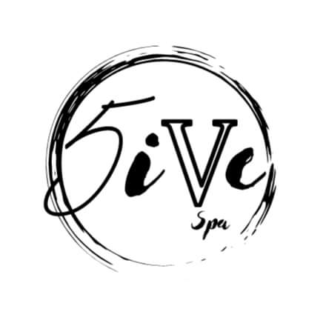

We are looking for a highly motivated and independent spa technician to join our team! At 555 Boutique & Spa we offer you the freedom of being able to set your own schedule that fits your needs! If you are up to date with your services and know how to provide excellent customer service, we’d love to meet you!

Who we are looking for:
- Licensed Massage Therapists
- Licensed Estheticians
- Nail Techs
- Permanent Makeup Artists

What we offer:
- Advertising & Marketing
- Scheduling Software
- Flexible Schedule
- Strong Clientele Base
- Linens & Towels
- On-site Washer & Dryer
& so much more!

Must hold a valid and current Nebraska license.
For more information or to set up an interview, contact Brandi at 402.580.6391 or email your resume to brandij.lmt@gmail.com

